**Question Answering System**



Bhanuja Nagore | Xun Peng | Radhika Maheshwari

nagore.b@husky.neu.edu, peng.xu@husky.neu.edu, maheshwari.r@husky.neu.edu

Spring 2018, Northeastern University

**Overview:**



Question answering (QA) is a popular researched problem in natural language processing. QA has been used to develop dialog systems and chatbots designed to simulate human conversation. Here we researched two different models for QA system.

First, We researched a learning model called memory networks. Memory networks reason with inference components combined with a long-term memory component; they learn how to use these jointly. The long-term memory can be read and written to, with the goal of using it for prediction. We investigate these models in the context of question answering (QA) where the long-term memory effectively acts as a (dynamic) knowledge base, and the output is a textual response.

Second, based on memory networks, we implemented a neural network with a recurrent attention model over a possibly large external memory. The architecture is a form of Memory Network but unlike the model in that work, it is trained end-to-end, and hence requires significantly less supervision during training, making it more generally applicable in realistic settings.

We evaluate them on a large-scale QA task, and a smaller, but more complex, toy task generated from a simulated world.

In the latter, we show the reasoning power of such models by chaining multiple supporting sentences to answer questions that require understanding the intentions of verbs.

**Approach:**



We utilize a novel recurrent neural network (RNN) architecture where the recurrence reads from a possibly large external memory multiple times before outputting a symbol. The model can be considered a continuous form of the Memory Networks. The continuity we present means that it can be trained end-to-end from input-output pairs, hence requires significantly less supervision during training, making it more generally applicable in realistic settings and to more tasks.

The model takes the set of inputs and stores it in the memory. The question as another input from the user and the answer of the question as output. The model writes all the inputs in the memory up to a fixed buffer size and then it finds a continuous representation for the inputs and the question. The continuous representation is then processed with many repetitions to get the answer as output. This allows back-propagation of the error signal through multiple memory accesses back to the input during training.

We start by describing our model in the single layer case, which implements a single memory hop operation. We then show it can be stacked to give multiple hops in memory to handle K hop operations.

**Dataset:**



The quest for knowledge is deeply human, and so it is not surprising that practically as soon as there were computers, and certainly as soon as there was natural language processing, we were trying to use computers to answer textual questions. In this project, we have taken the Babi dataset to implement the Question Answering System and know how to it works in detail.

The Facebook bAbI dataset is a synthetic dataset of 20 question-answering tasks. Each task targets a specific skill that a general reasoning agent would be expected to have, such as answering yes/no questions or performing deduction over multiple sentences.

**Training Set Size:** Each of the 20 tasks consists of 1,000 training examples and 1,000 test examples. The tasks are generated from a simulation of characters and objects interacting in a small, closed world, which produces ground text describing the scene and question/answer pairs. Supervision is provided in the form of answers for each of the questions and the location of relevant sentences in the input required to answer the question. For development, we randomly partition the 1,000 training examples for each task into 900 example training sets and 100 example development sets. To answer the questions correctly, the models must be able to perform induction, deduction, fact chaining, and more.

The dataset presents tasks for testing text understanding and reasoning.

The aim is that each task tests a unique aspect of text and reasoning, and hence test different capabilities of learning models.

All of the tasks are noiseless and a human able to read that language can potentially achieve 100% accuracy. The data itself is produced using a simple simulation of characters and objects moving around and interacting in locations.

The file format for each task is as follows:

ID text

ID text

ID text

ID question[tab]answer[tab]supporting fact IDS. ...

The IDs for a given “story” start at 1 and increase. When the IDs in a file reset back to 1 you can consider the following sentences as a new “story”. Supporting fact IDs only ever reference the sentences within a “story”.

Described below are different types of tasks in our dataset:

**Single Supporting Fact:** Task 1 consists of questions where a previously given single supporting fact, potentially amongst a set of other irrelevant facts, provides the answer.

**Two or Three Supporting Facts:** A harder task is to answer questions where two supporting statements have to be chained to answer the question.

**Two or Three Argument Relations:** To answer questions the ability to differentiate and recognize subjects and objects is crucial. In task 4 we consider the extreme case where sentences feature reordered words, i.e. a bag-of-words will not work.

**Yes/No Questions:** Task 6 tests, on some of the simplest questions possible (specifically, ones with a single supporting fact), the ability of a model to answer true/false type questions like “Is John in the playground?”.

**Counting and Lists/Sets:** Task 7 tests the ability of the QA system to perform simple counting operations, by asking about the number of objects with a certain property, e.g. “How many objects is Daniel holding?”.

**Simple Negation and Indefinite Knowledge:** Tasks 9 and 10 test slightly more complex natural language constructs. Task 9 tests one of the simplest forms of negation, that of supporting facts that imply a statement is false.

**Basic Coreference, Conjunctions and Compound Coreference:** Task 11 tests the simplest type of coreference, that of detecting the nearest referent, e.g. “Daniel was in the kitchen. Then he went to the studio.”

**Time Reasoning:** While our tasks so far have included time implicitly in the order of the statements, task 14 tests understanding the use of time expressions within the statements.

**Basic Deduction and Induction:** Task 15 tests basic deduction via inheritance of properties, e.g. “Sheep are afraid of wolves. Gertrude is a sheep. What is Gertrude afraid of?”.

**Positional and Size Reasoning Task:** 17 tests spatial reasoning by asking questions about the relative positions of colored blocks.

**Path Finding:** The goal of task 19 is to find the path between locations: given the description of various locations, it asks: how do you get from one to another?.

**Agent’s Motivations:** Finally, task 20 questions, in the simplest way possible, why an agent performs an action. It addresses the case of actors being in a given state (hungry, thirsty, tired, . . . ) and the actions they then take, e.g. it should learn that hungry people might go to the kitchen, and so on.

**Technical Approach:**



# Memory Networks

Memory Networks combine inputs with attention on memories to provide reasoned outputs. Limits the first iteration’s scope to be as simple as possible. It consists of a recurrent controller module that accepts an initial query. To start, its memory is loaded with a set of facts. The query and facts are bag-of-words vectors. The controller predicts an attention vector (with a supervision signal) to choose a fact. It reads the chosen memory to update its hidden state. After several repetitions, or hops, it formulates an output. The output ranks possible responses from a dictionary of words. Error signals back-propagate through the network via the output and the supervised attention episodes.

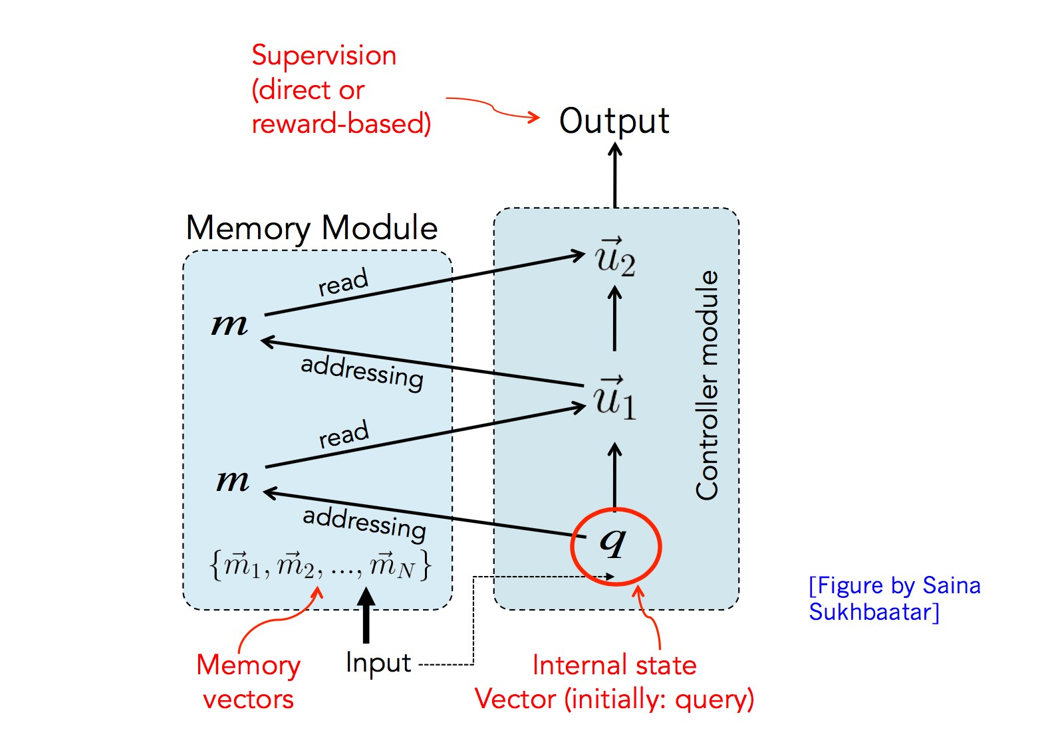

Each benchmark consists of a set of short stories. Each story is a sequence of statements about an evolving situation. The model should read a single story and answer one or more questions about it. Within a benchmark, the stories test the same skill. Across the different benchmarks, the skills get more difficult.

Example –

* John was in the bedroom.
* Bob was in the office.
* John went to the kitchen.
* Bob travelled back home.
* Where is John? A: kitchen

Factoid question/answer with single supporting fact



Factoid QA with two supporting facts

Factoid QA with three supporting facts

Two argument relations: subject versus object

Three argument relations

Yes/no questions

Counting

Lists/sets

Simple negation

Indefinite knowledge

Basic coreference

Conjunction

Compound coreference

Time manipulation

* Basic deduction

**End to End Memory Network**

End-to-end Memory Network (MemN2N) learns without attention supervision. It uses softattention (a probability vector) to read the memory. Thus, it is fully-differentiable and can learn from output supervision alone. The newer model still fails on some toy benchmark tasks. Yet, it succeeds on several real-world benchmarks, such as children’s books and news question sets.

Soft attention version of MemN2N

• Flexible read-only memory

• Multiple memory lookups (hops)

• Can consider multiple memory before deciding output

• More reasoning power

• End-to-end training.

• Only needs final output for training

• Simple back-propagation

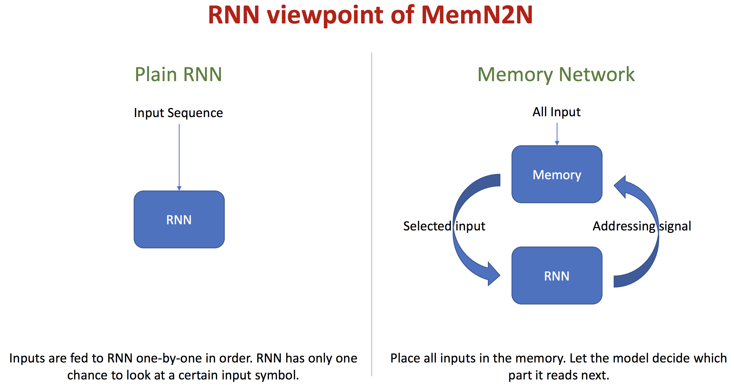

4 steps of MemN2N implementation:

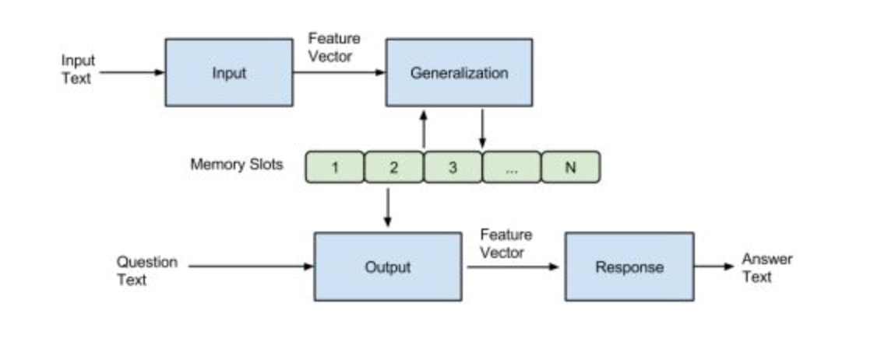

* I (input): converts to word embeddings X(dialog).
* G (generalization): stores x in next available slot Mn() ➢ (output): Loops over all memories k=1 or 2 times:

1st loop max: finds best match Mi with X(question).

2nd loop max: finds best match Mj with (x, Mi) ➢ The output o is represented with (x, Mi, Mj).

* R (response): ranks all words in the dictionary given O and returns best single word.

**Code with Documentation:**

**Model-**

1. **Set parameters which will be used during building End-to-end Memory Networks**
   1. "edim", 20, "internal state dimension [20]"
   2. "nhop", 3, "number of hops [3]"
   3. "mem_size", 50, "maximum number of sentences that can be encoded into memory [50]"
   4. "batch_size", 32, "batch size to use during training [32]"
   5. "nepoch", 100, "number of epoch to use during training [100]"
   6. "anneal_epoch", 25, "anneal the learning rate every <anneal_epoch> epochs [25]"
   7. "babi_task", 1, "index of bAbI task for the network to learn [1]"
   8. "init_lr", 0.01, "initial learning rate [0.01]"
   9. "anneal_rate", 0.5, "learning rate annealing rate [0.5]"
   10. "init_mean", 0., "weight initialization mean [0.]"
   11. "init_std", 0.1, "weight initialization std [0.1]"
   12. "max_grad_norm", 40, "clip gradients to this norm [40]"
   13. "data_dir", "./data", "dataset directory [./data]"
   14. "checkpoint_dir", "./checkpoints", "checkpoint directory [./checkpoints]"
   15. "lin_start", False, "True for linear start training, False for otherwise [False]"
   16. "is_test", False, "True for testing, False for training [False]"
   17. "show_progress", False, "print progress [False]"

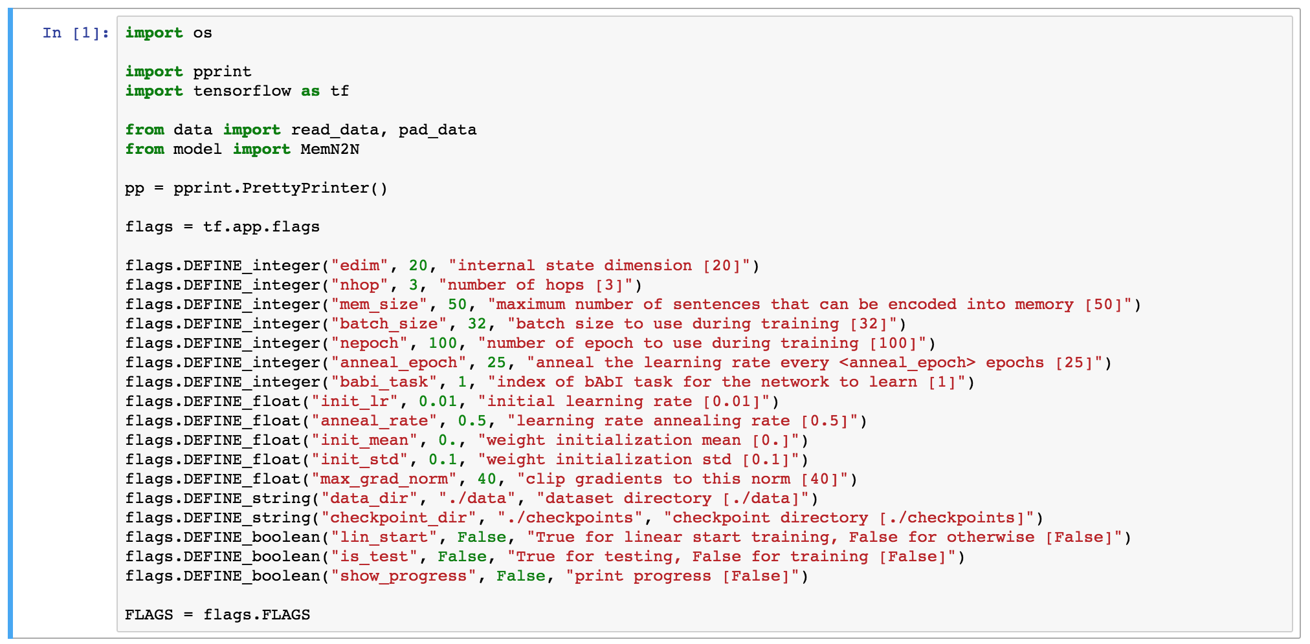

2. **Data preprocessing**

1. Word2idx represents a map between each word and its index in the dictionary
2. Max_words represents the maximum words in each sentence
3. max_sentences represents the maximum sentences in a story
4. load data for train, valid and test
5. Pad_data dataset
6. set other parameters to FLAGS and used to train the model
7. create a TensorFlow session and build and train the model inside this session

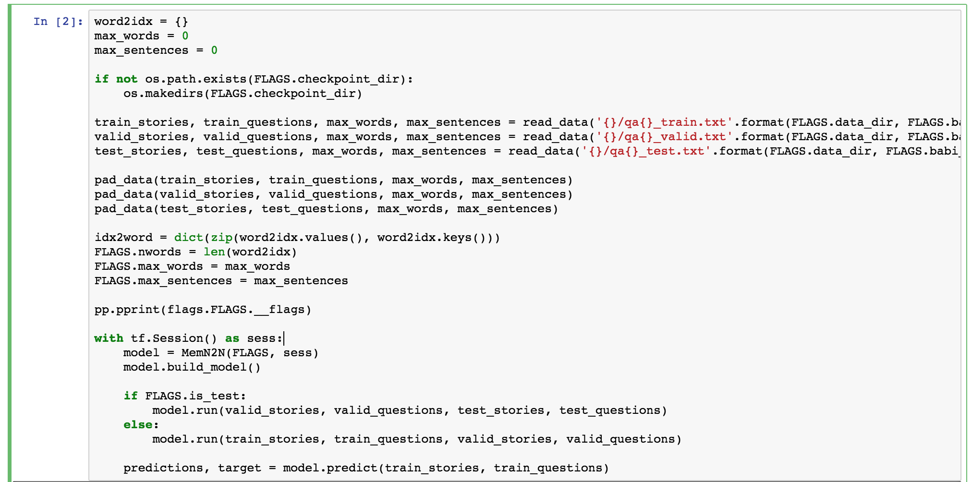

3. **Create memory network model class and initialize it**

1. Set all parameters to models
2. Set 4 placeholder for this model
   1. query
   2. time
   3. target
   4. context(dialog)

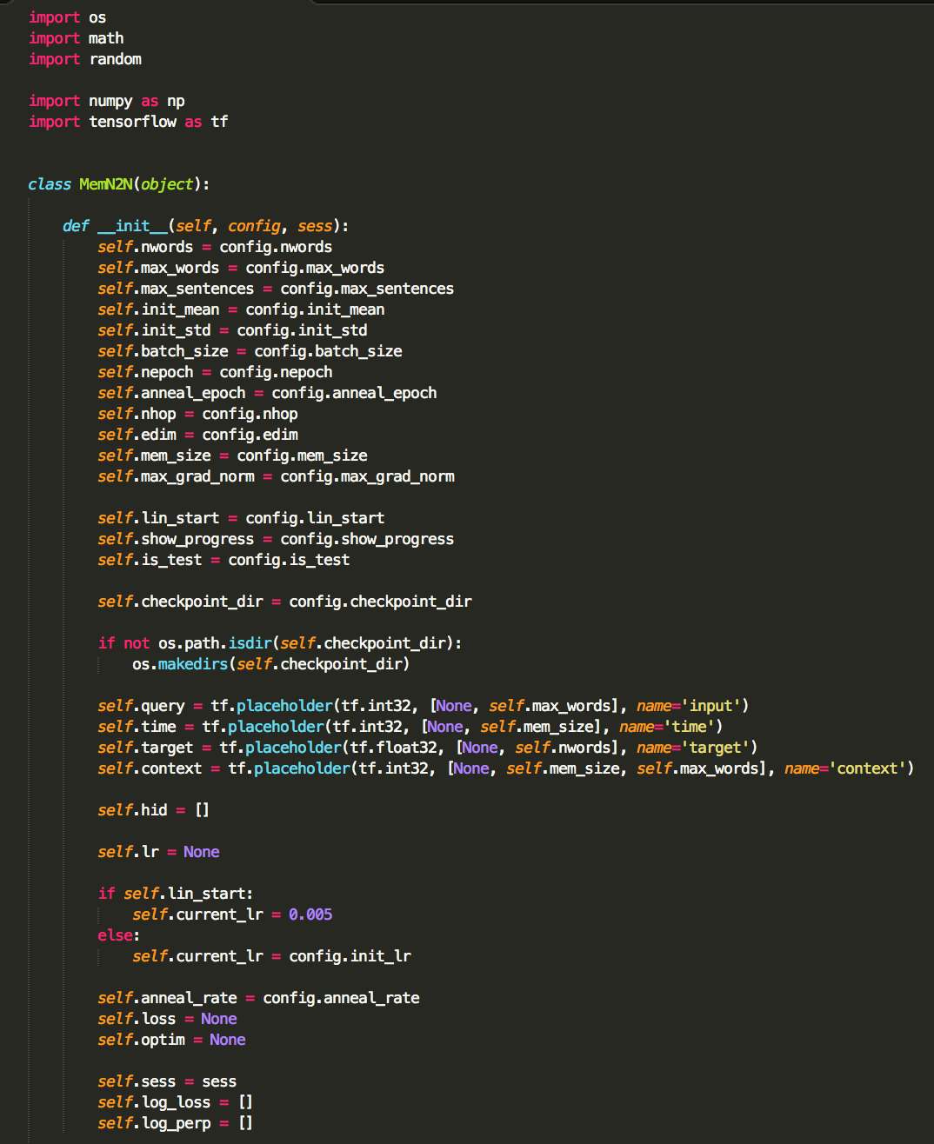

1. **Build the model**
2. Build Memory

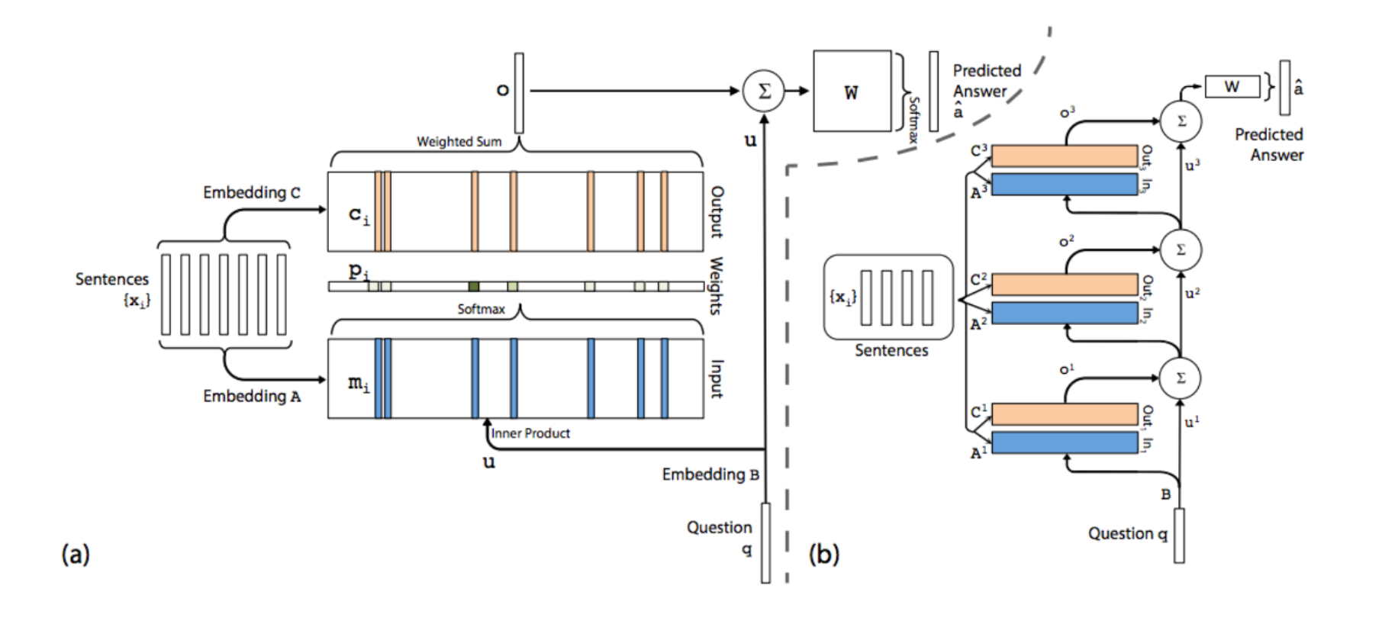

**Memory Architecture**

2.1 Single Layer

We start by describing our model in the single layer case, which implements a single memory hop operation. We then show it can be stacked to give multiple hops in memory.

**Input memory representation:** Suppose we are given an input set x1 , .., xi to be stored in memory. The entire set of {xi} are converted into memory vectors {mi} of dimension d computed by embedding each xi in a continuous space, in the simplest case, using an embedding matrix A (of size d × V ). The query q is also embedded (again, in the simplest case via another embedding matrix B with the same dimensions as A) to obtain an internal state u. In the embedding space, we compute the match between u and each memory mi by taking the inner product followed by a softmax:

pi = Softmax(uT mi).

where Softmax(zi ) = ezi / j ezj . Defined in this way p is a probability vector over the inputs.

**Output memory representation:** Each xi has a corresponding output vector ci (given in the simplest case by another embedding matrix C). The response vector from the memory o is then a sum over the transformed inputs ci, weighted by the probability vector from the input:

o = $\sum_{i}{}P_{i}C_{i}$

Because the function from input to output is smooth, we can easily compute gradients and back- propagate through it. Other recently proposed forms of memory or attention take this approach, notably Bahdanau *et al.* [2] and Graves *et al.* [8], see also [9].

**Generating the final prediction:** In the single layer case, the sum of the output vector o and the input embedding u is then passed through a final weight matrix W (of size V × d) and a softmax to produce the predicted label:

aˆ = Softmax(W (o + u))

The overall model is shown in Fig. 1(a). During training, all three embedding matrices A, B and C, as well as W are jointly learned by minimizing a standard cross-entropy loss between aˆ and the true label a. Training is performed using stochastic gradient descent (see Section 4.2 for more details).

2.2 Multiple Layers

We now extend our model to handle K hop operations. The memory layers are stacked in the following way:

* The input to layers above the first is the sum of the output ok and the input uk from layer k (different ways to combine ok and uk are proposed later):
$$u^{k+1}=u^{k}+o^{k}$$

* Each layer has its own embedding matrices Ak,Ck, used to embed the inputs {xi}. However, as discussed below, they are constrained to ease training and reduce the number of parameters.
* At the top of the network, the input to W also combines the input and the output of the top memory layer: aˆ = Softmax(W uK +1 ) = Softmax(W (oK + uK )).
  1. 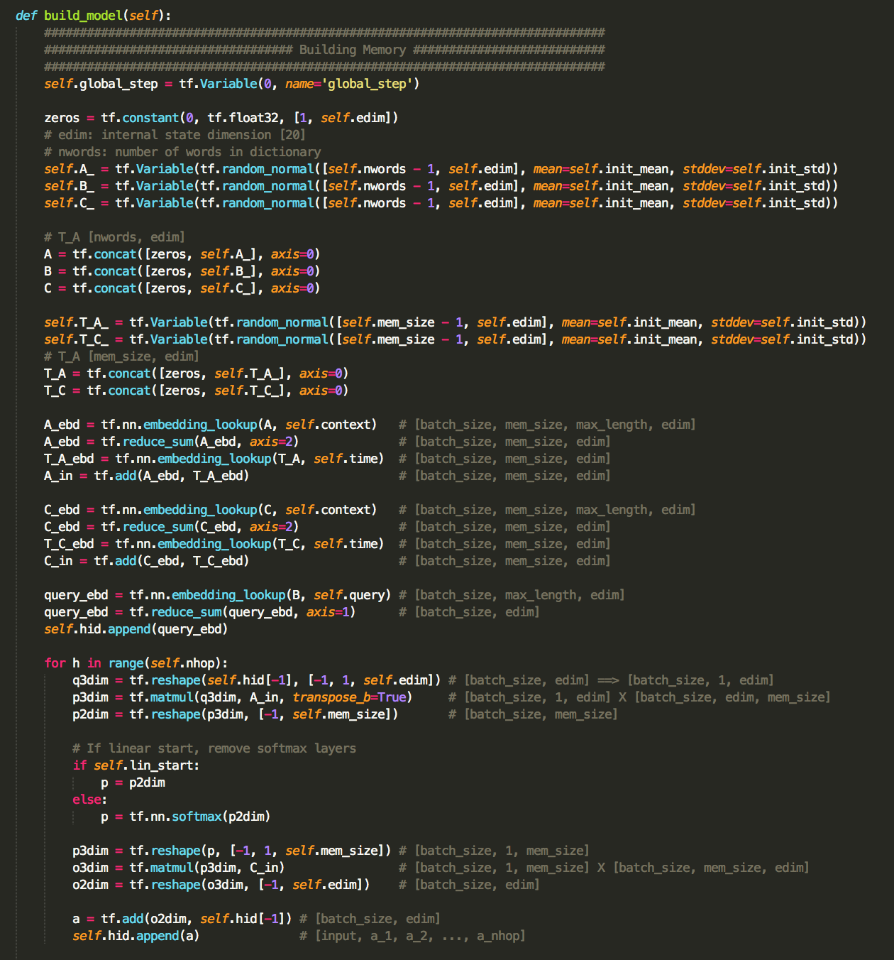
  2. Calculate lost function
     1. use cross entropy to calculate the lost function
     2. Use gradient descent to optimize the cost function
  3. 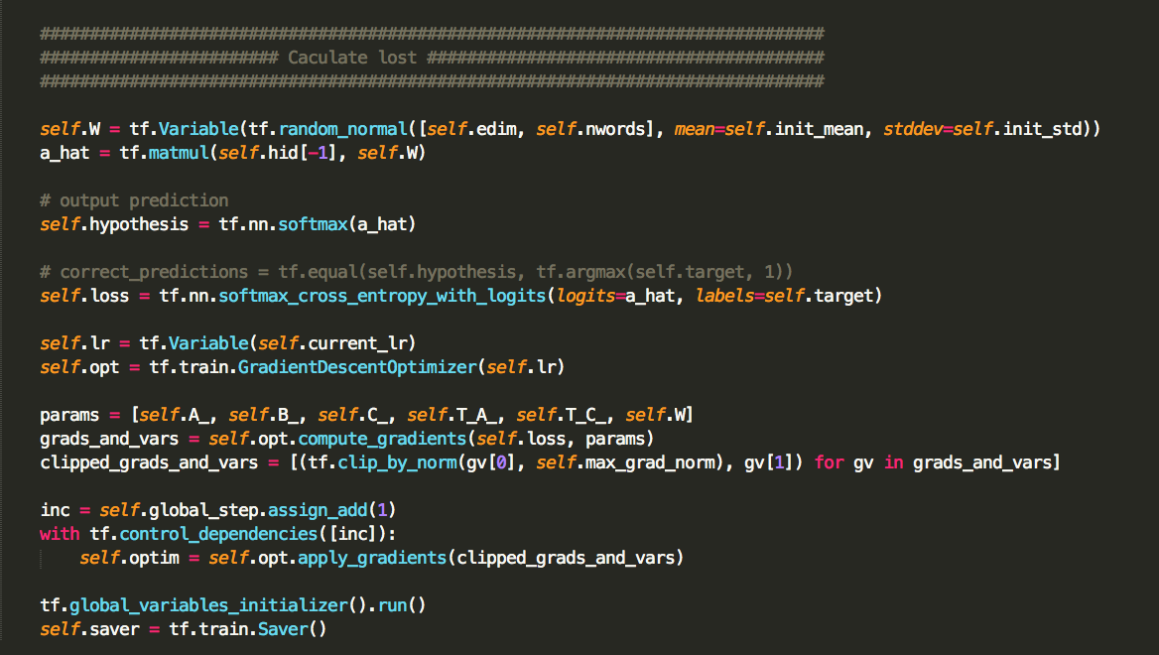

1. Run the memory network
   1. We set an epoch to 20
   2. Run the model using training dataset
   3. Run the model using testing dataset
   4. Decrease the learning rate by 50 percent each 25 epoch
   5. Save the model each 10 epoch

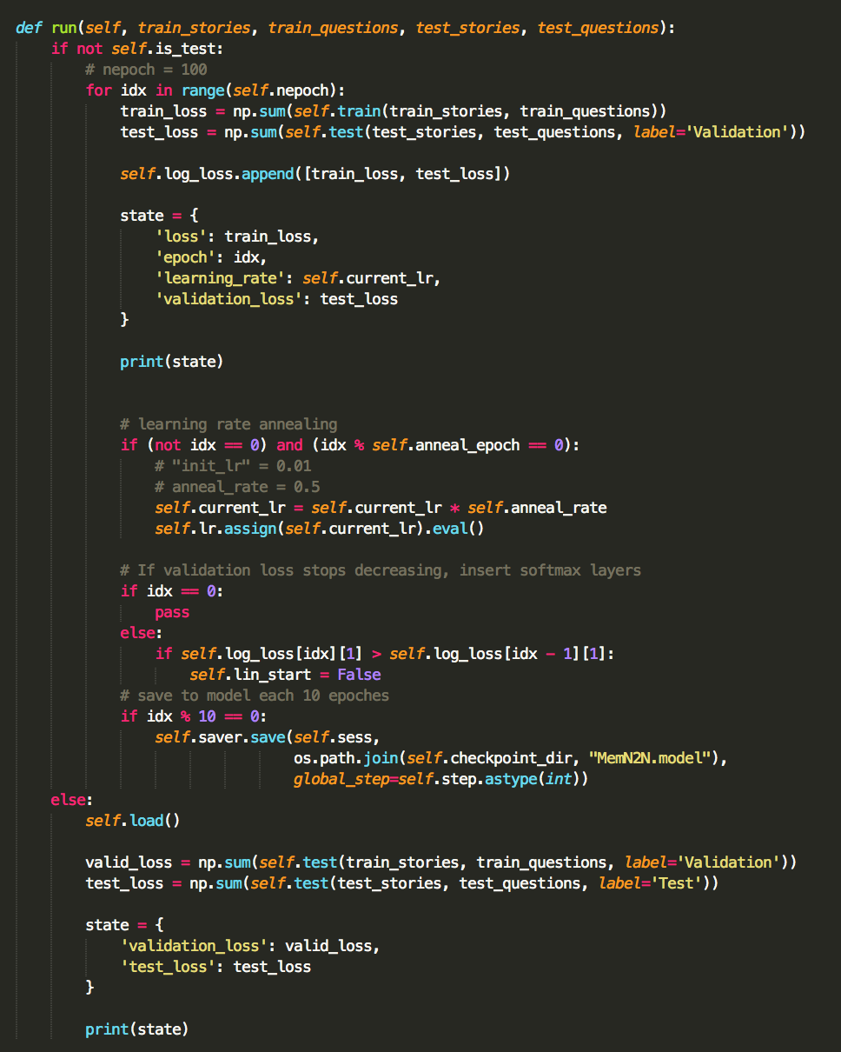

3. train method:

1. set batch_size to 32
2. give the input query, time, target, context as the placehold
3. TensorFlow runs the sess with all place hold
4. return cost function

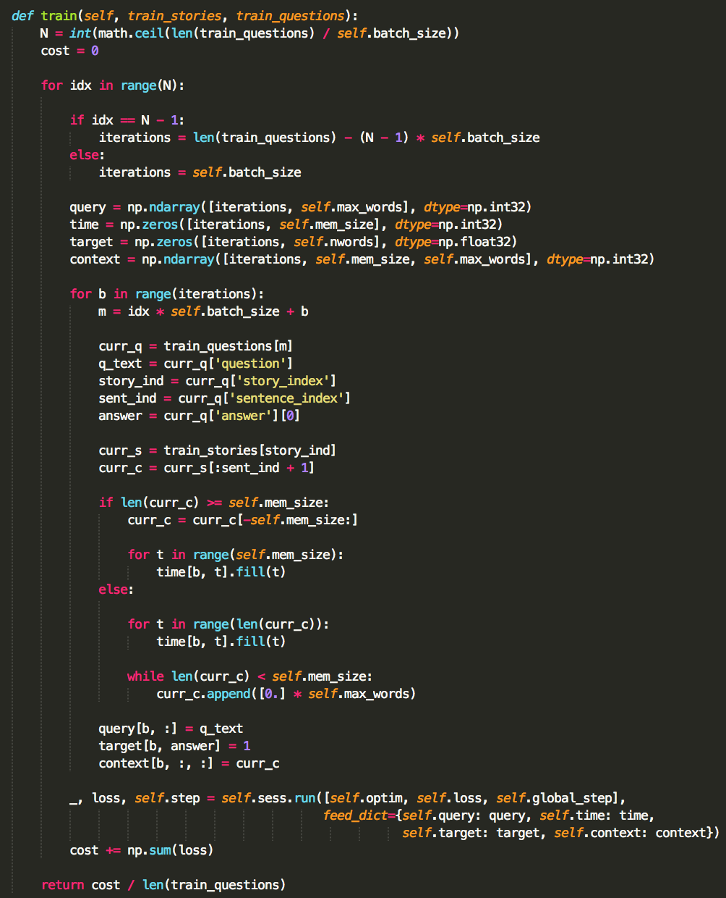

**Result:**

lost during training and testing

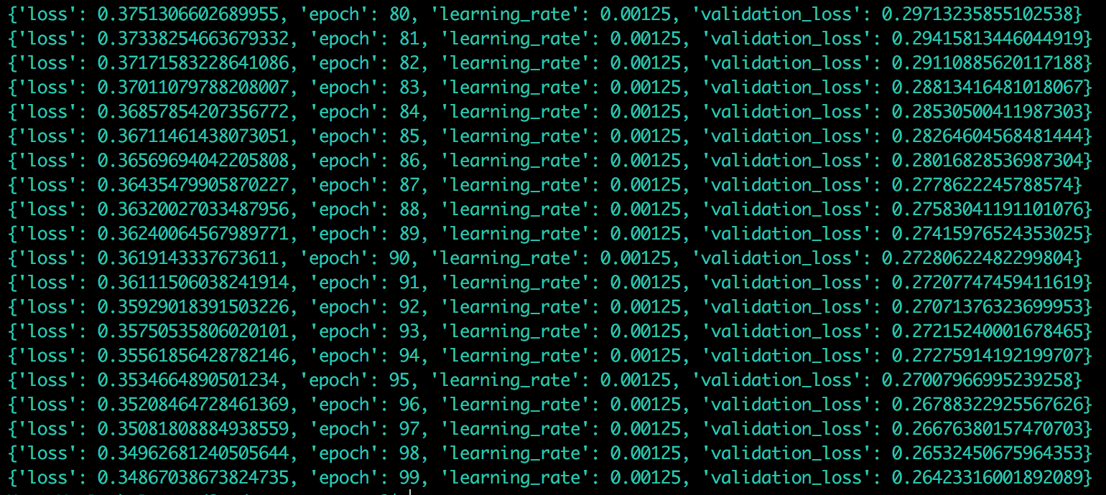

give a random story and predict the result based on the question it gives

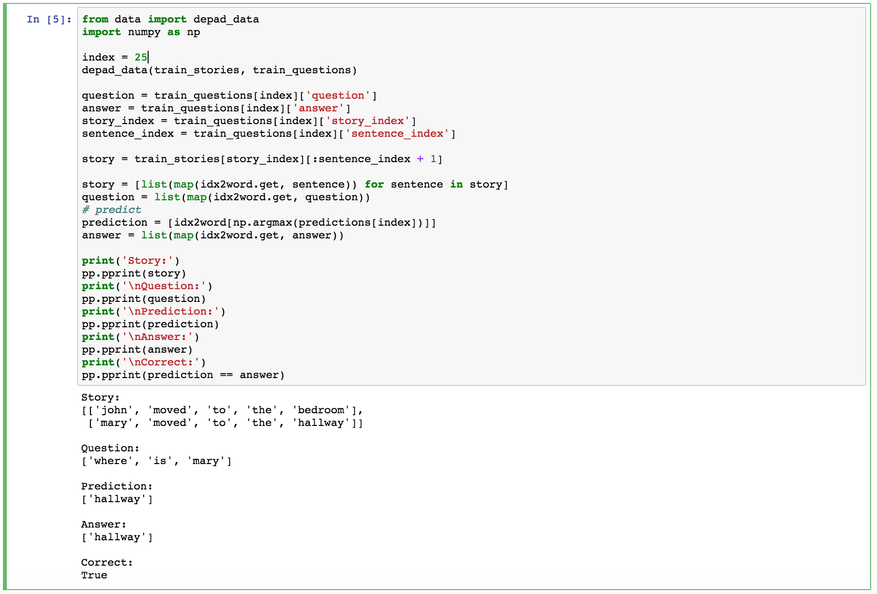

# Document Clustering with Python Nltk –

NLTK is a leading platform for building Python programs to work with human language data. It provides easy-to-use interfaces to over 50 corpora and lexical resources such as WordNet, along with a suite of text processing libraries for classification, tokenization, stemming, tagging, parsing, and semantic reasoning, wrappers for industrial-strength NLP libraries.

NLTK has been called “a wonderful tool for teaching, and working in, computational linguistics using Python,” and “an amazing library to play with natural language.”

# Clustering text documents using k-means



This is an example showing how the scikit-learn can be used to cluster documents by topics using a bag-of-words approach. This example uses a scipy.sparse matrix to store the features instead of standard numpy arrays.

Two feature extraction methods can be used in this example:

* Tfidf Vectorizer uses a in-memory vocabulary (a python dict) to map the most frequent words to features indices and hence compute a word occurrence frequency (sparse) matrix. The word frequencies are then reweighted using the Inverse Document Frequency (IDF) vector collected feature-wise over the corpus.
* Hashing Vectorizer hashes word occurrences to a fixed dimensional space, possibly with collisions. The word count vectors are then normalized to each have l2-norm equal to one (projected to the Euclidean unit-ball) which seems to be important for k-means to work in high dimensional space.

HashingVectorizer does not provide IDF weighting as this is a stateless model (the fit method does nothing). When IDF weighting is needed it can be added by pipelining its output to a TfidfTransformer instance.

Two algorithms are demoed: ordinary k-means and its more scalable cousin minibatch k-means.

Note: as k-means is optimizing a non-convex objective function, it will likely end up in a local optimum. Several runs with independent random init might be necessary to get a good convergence.

Analysis using the following Steps:

* Stopwords, stemming, and tokenization
* Tf-idf and document similarity
* K-means clustering
* Multidimensional scaling
* Visualizing document clusters
* Hierarchical document clustering
* Latent Dirichlet Allocation (LDA)

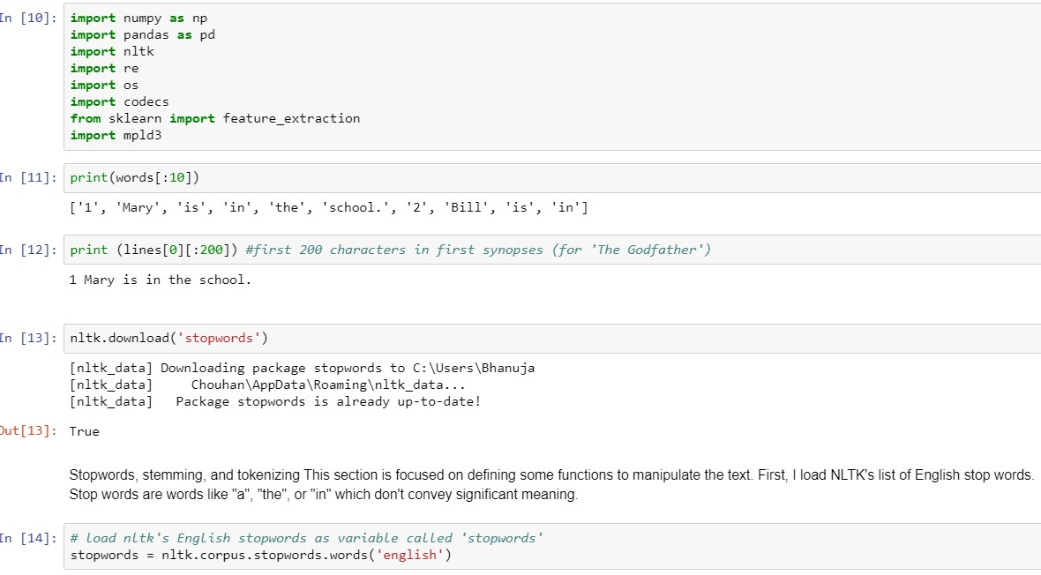

Below I define two functions:

tokenize_and_stem: tokenizes (splits the text into a list of its respective words (or tokens) and also stems each token tokenize_only: tokenizes the para only I use both these functions to create a dictionary which becomes important in case I want to use stems for an algorithm, but later convert stems back to their full words for presentation purposes.

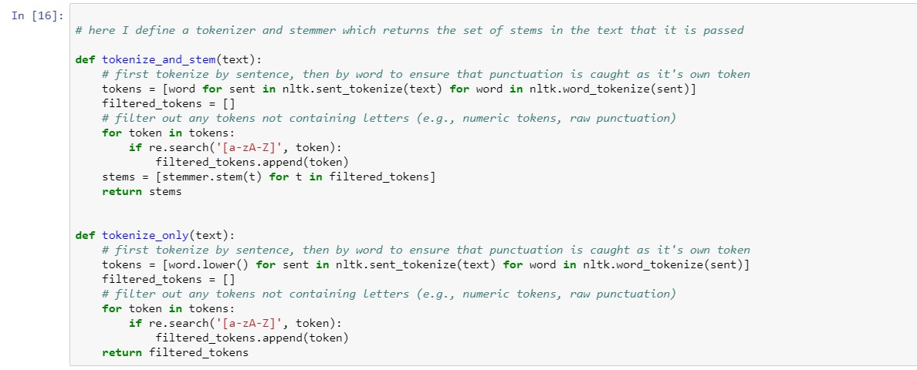

Stemming/tokenizing and tokenizing functions to iterate over the list of text para to create two vocabularies: one stemmed and one only tokenized

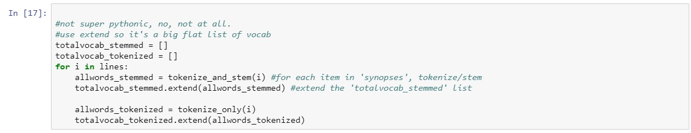

Using these two lists, I create a pandas DataFrame with the stemmed vocabulary as the index and the tokenized words as the column. The benefit of this is it provides an efficient way to look up a stem and return a full token. The downside here is that stems to tokens are one to many: the stem 'run' could be associated with 'ran', 'runs', 'running', etc

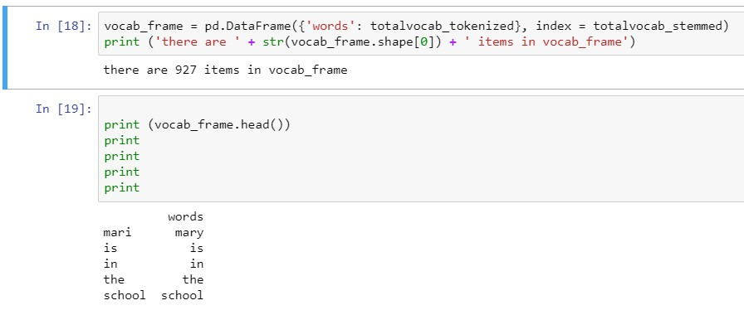

Tf-idf and document similarity

Here, I define term frequency-inverse document frequency (tf-idf) vectorizer parameters and then convert the text list into a tf-idf matrix.

To get a Tf-idf matrix, first count word occurrences by document. This is transformed into a documentterm matrix (dtm). This is also just called a term frequency matrix.

Then apply the term frequency-inverse document frequency weighting: words that occur frequently within a document but not frequently within the corpus receive a higher weighting as these words are assumed to contain more meaning in relation to the document.

A couple things to note about the parameters I define below:

max_df: this is the maximum frequency within the documents a given feature can have to be used in the tfi-idf matrix. If the term is in greater than 80% of the documents it probably cares little meanining min_idf: this could be an integer (e.g. 5) and the term would have to be in at least 5 of the documents to be considered. Here I pass 0.2; the term must be in at least 20% of the document. I found that if I allowed a lower min_df I ended up basing clustering on names--for example "Michael" or "Tom" are names found in several of the text use these names frequently, but the names carry no real meaning.

ngram_range: this just means I'll look at unigrams, bigrams and trigrams.

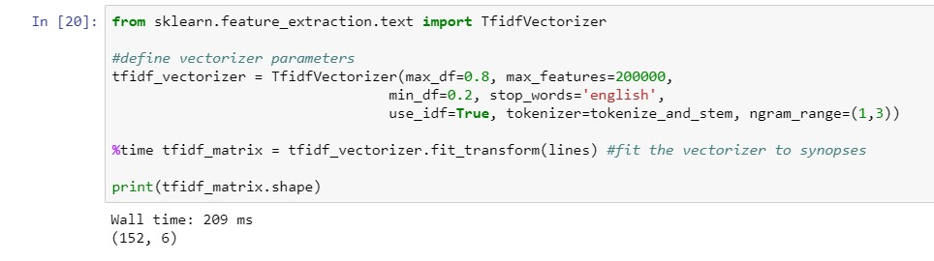

dist is defined as 1 - the cosine similarity of each document. Cosine similarity is measured against the tf-idf matrix and can be used to generate a measure of similarity between each document and the other documents in the corpus (each synopsis among the synopses). Subtracting it from 1 provides cosine distance which I will use for plotting on a euclidean (2-dimensional) plane. Note that with dist it is possible to evaluate the similarity of any two or more synopses.

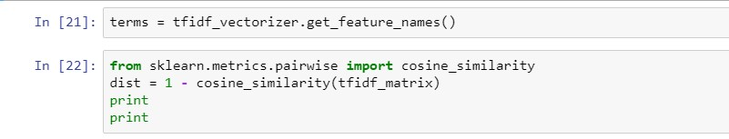

K-means clustering Using the tf-idf matrix, run a slew of clustering algorithms to better understand the hidden structure within the text. I first chose k-means. K-means initializes with a pre-determined number of clusters (I chose 5). Each observation is assigned to a cluster (cluster assignment) so as to minimize the within cluster sum of squares. Next, the mean of the clustered observations is calculated and used as the new cluster centroid. Then, observations are reassigned to clusters and centroids recalculated in an iterative process until the algorithm reaches convergence.

Several runs for the algorithm to converge a global optimum as k-means is susceptible to reaching local optima.

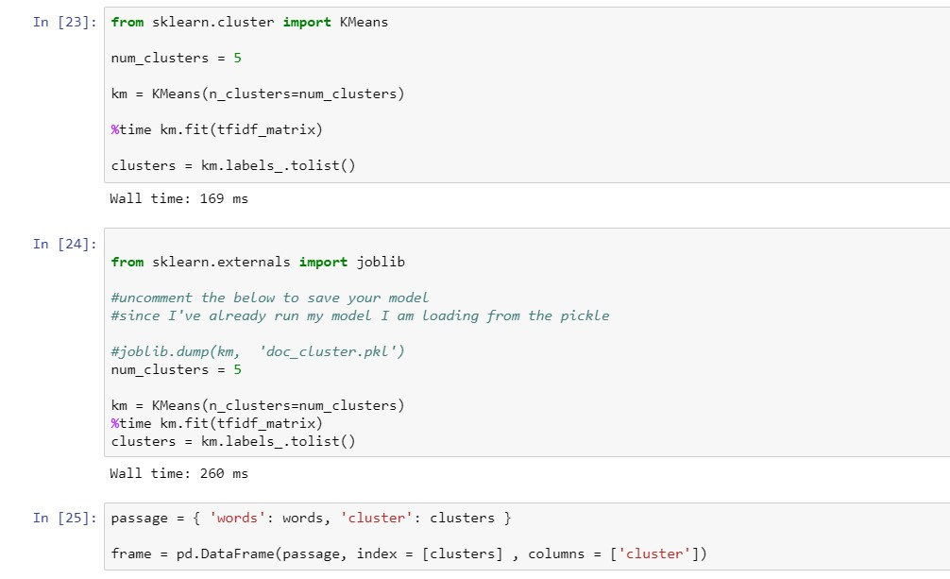

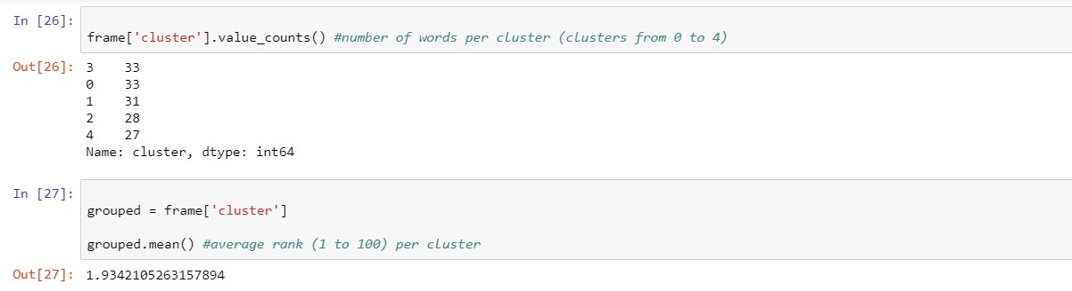

Indexing and sorting on each cluster to identify which are the top n (I chose n=6) words that are nearest to the cluster centroid. This gives a good sense of the main topic of the cluster.



**Visualizing document clusters**

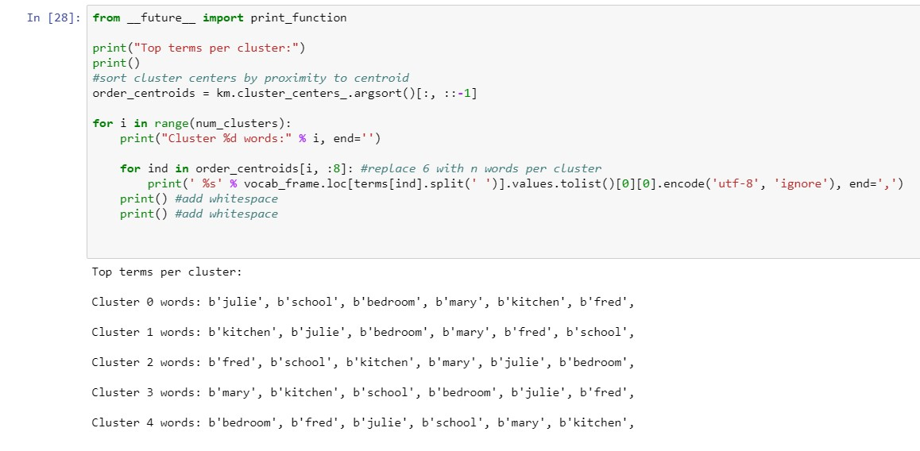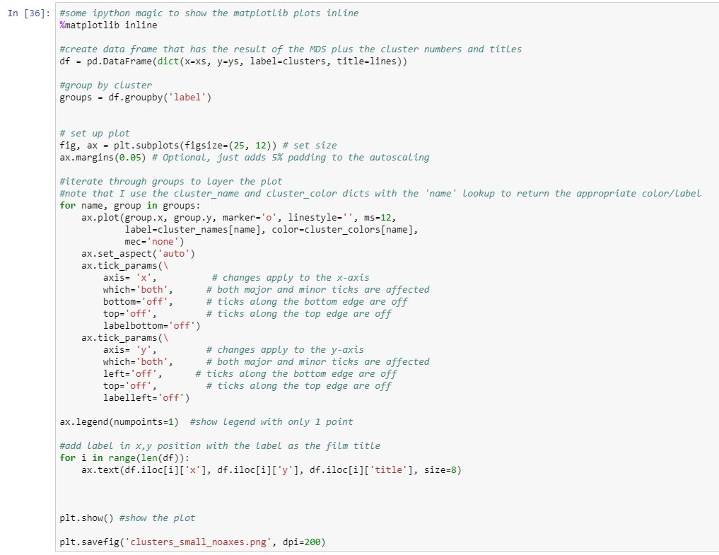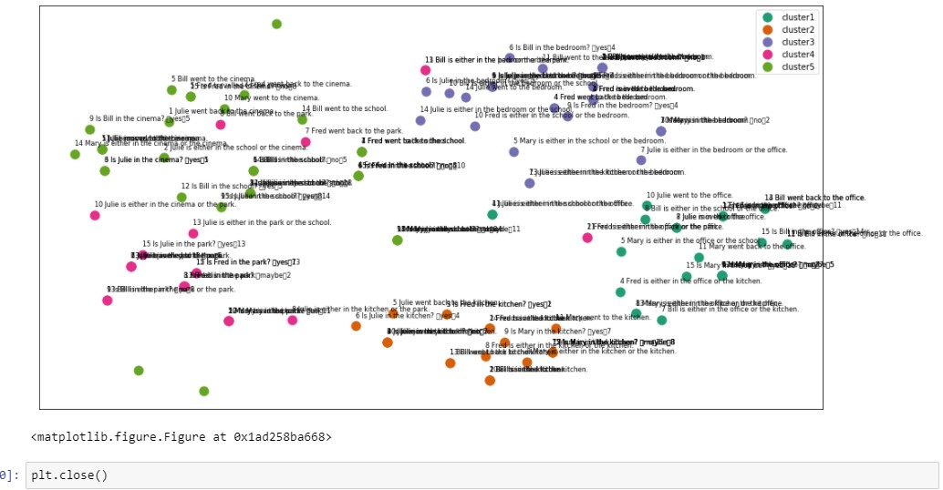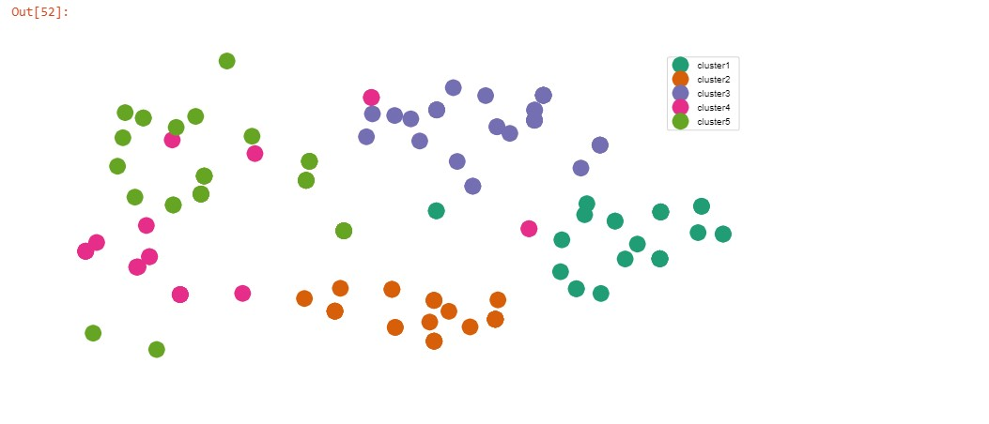

Hierarchical clustering Now that I was successfuly able to cluster and plot the documents using kmeans, I wanted to try another clustering algorithm. I chose the Ward clustering algorithm because it offers hierarchical clustering. Ward clustering is an agglomerative clustering method, meaning that at each stage, the pair of clusters with minimum between-cluster distance are merged. I used the precomputed cosine distance matrix (dist) to calclate a linkage_matrix, which I then plot as a dendrogram.

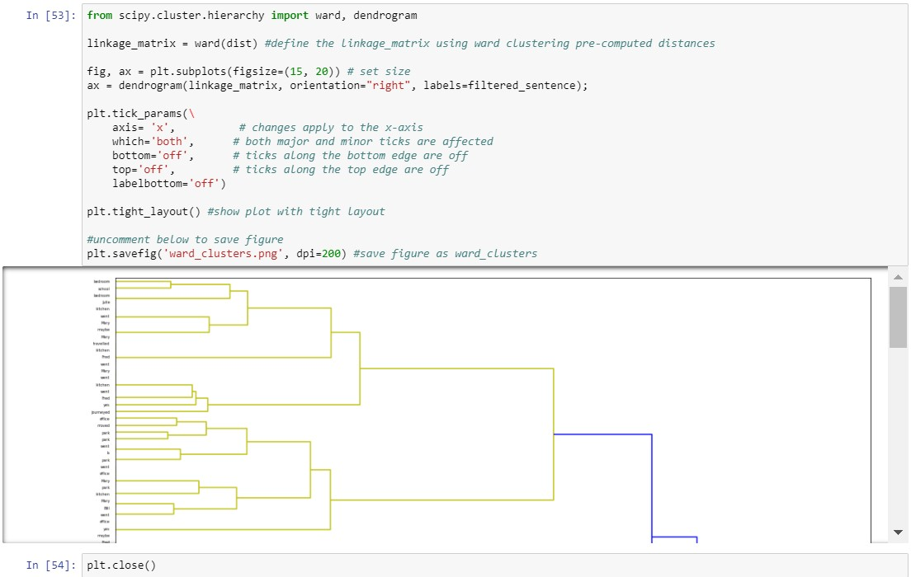

Latent Dirichlet Allocation This section focuses on using Latent Dirichlet Allocation (LDA) to learn yet more about the hidden structure within the top 100 lines. LDA is a probabilistic topic model that assumes documents are a mixture of topics and that each word in the document is attributable to the document's topics. There is quite a good high-level overview of probabilistic topic models

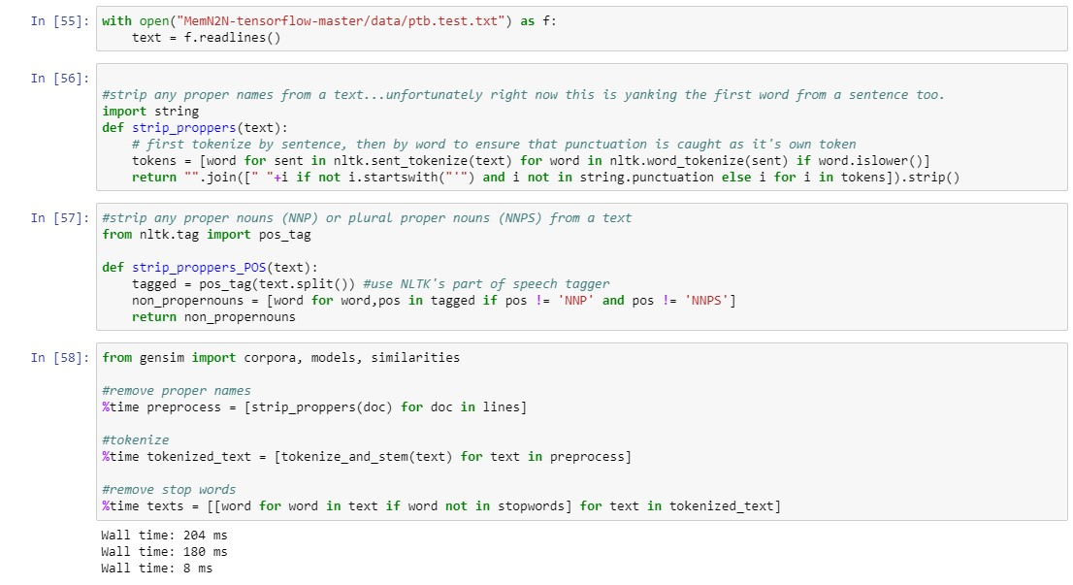

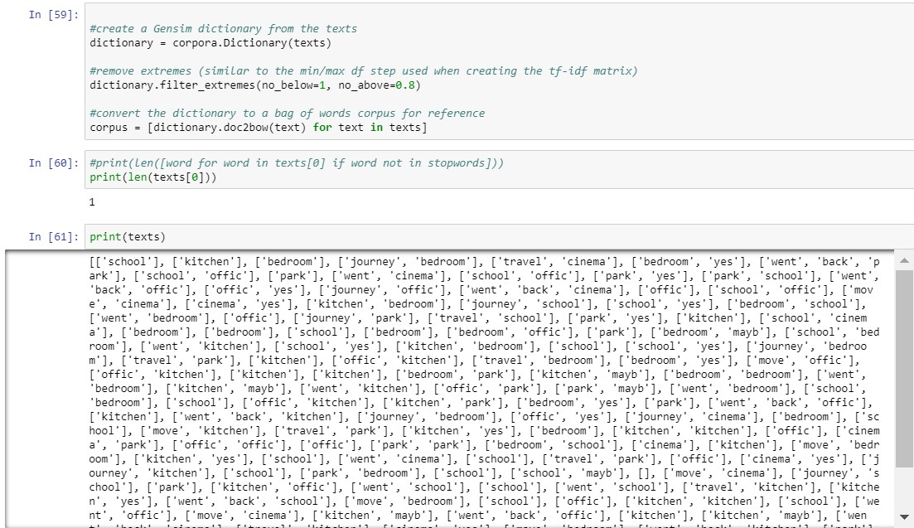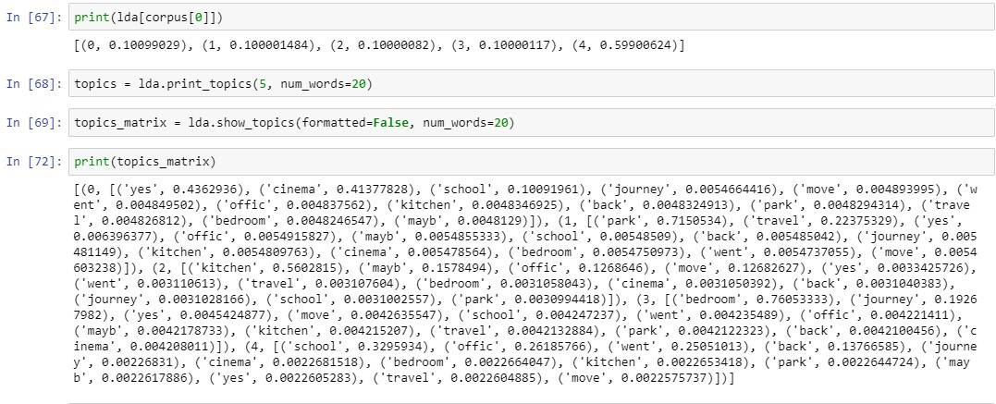

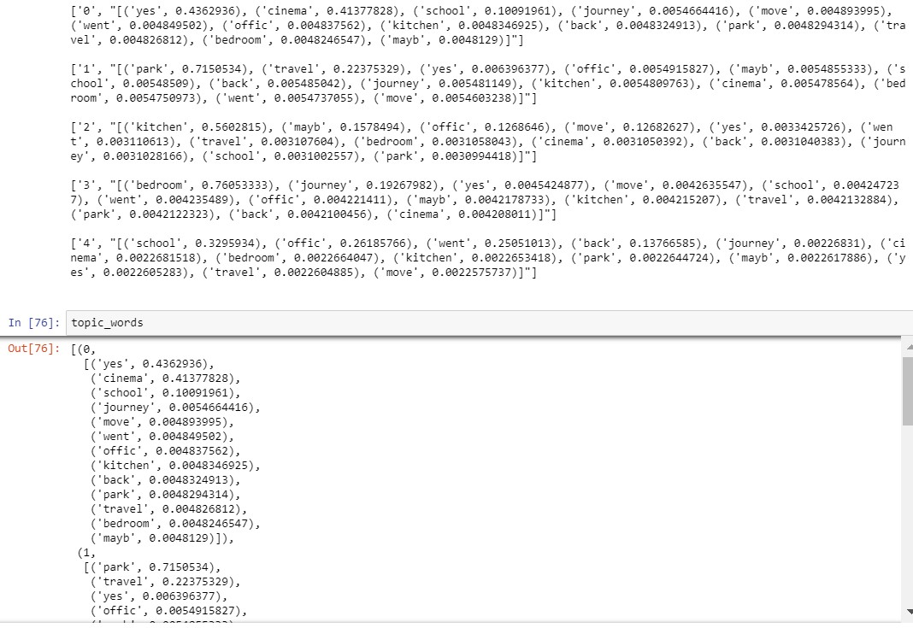

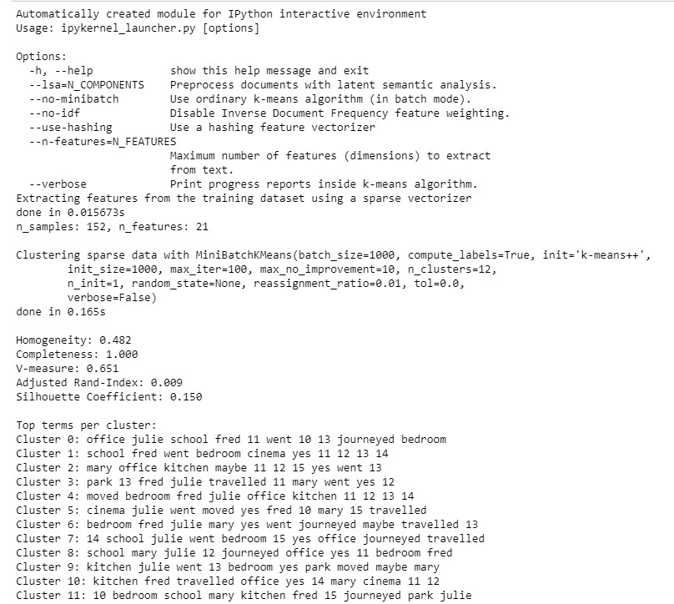

# Data Analysis on a part of the dataset



In this part of the analysis, we are trying to figure out how many supporting facts and sentences are related to one question. We have taken a part of the test data to do the analysis.

**Step 1:**

Here I am opening the data and reading the file.

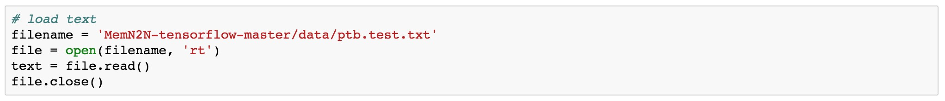

**Step 2:**

Printing the data to see how it looks like.

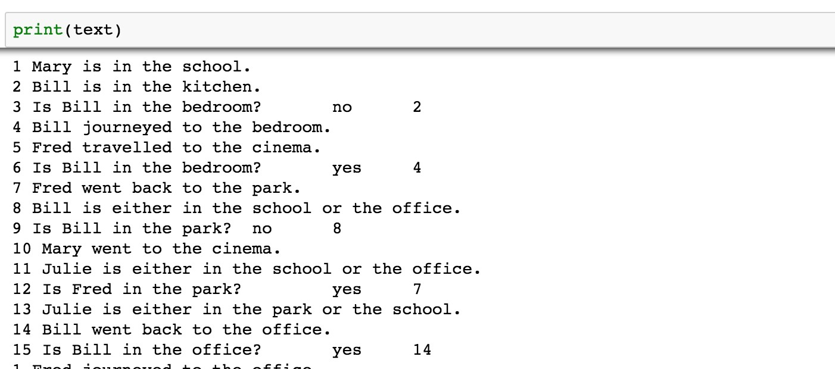

**Step 3:**

Imported nltk and downloaded nltk’s package ‘punkt’. This package is used to downloadsentence tokenizer. We have further downloaded and imported sent_tokenizer from nltk.tokenize.

This tokenizer is used which divides a string into substrings by splitting on the specified string. Therefore, it splits a string into a list of sentences.

Since our data is in string right now, we out tokenizing it into sentences so as to get a proper and meaningful analysis.

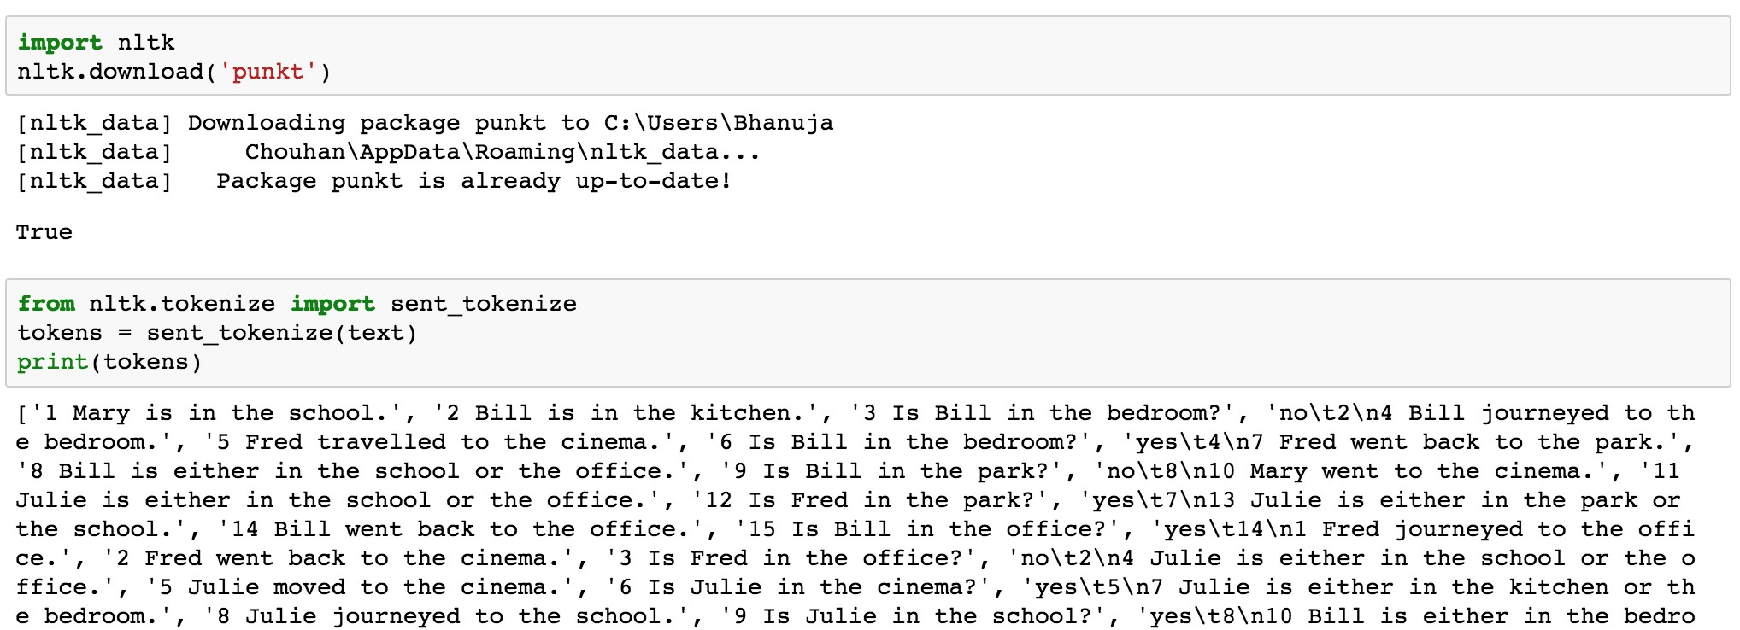

**Step 4:**

Imported ‘Regular Expressions’ to search for all the questions in our dataset.

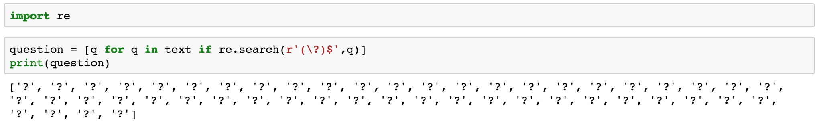

**Step 5:**

Imported Counter from collections package to count the number of questions in our dataset. As we can see, there are 50 questions.



**Step 6:**

Similarly, we have searched for all the sentences ending with ‘.’ to know the number of supporting facts and sentences for each question approximately. As we can see, there are 99 questions.

Therefore, there are two sentences (one supporting fact) for each question on an average.

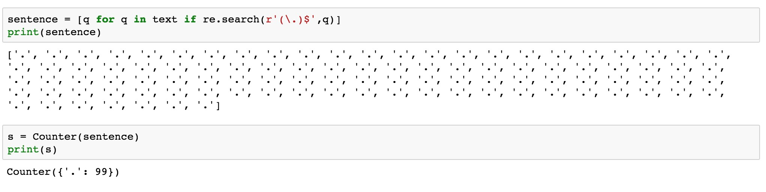

# Sentiment Analysis on a part of the dataset



Sentiment Analysis is the process of computationally identifying and categorizing opinions expressed in a piece of text, especially in order to determine whether the writer's attitude towards a particular topic, product, etc., is positive, negative, or neutral.

In this case, we have used Vader – SentimentIntensityAnalyzer.

VADER (Valence Aware Dictionary for sEntiment Reasoning) is a model used for text sentiment analysis that is sensitive to both polarity (positive/negative) and intensity (strength) of emotion. VADER text sentiment analysis uses a human-centric approach, combining qualitative analysis and empirical validation by using human raters and the wisdom of the crowd.

It combines a dictionary, which maps lexical features to emotion intensity, and five simple heuristics, which encode how contextual elements increment, decrement, or negate the sentiment of text.

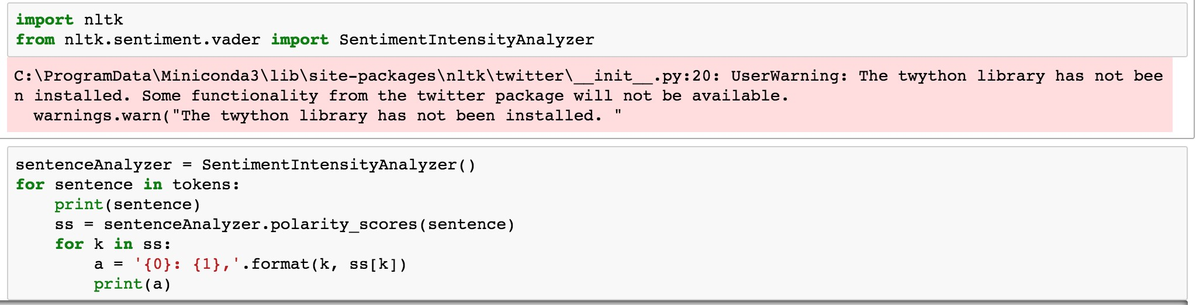

The VADER algorithm outputs sentiment scores to 4 classes of sentiments:

* neg: Negative
* neu: Neutral
* pos: Positive
* compound: Compound (i.e. aggregated score)

One example from our dataset when Sentiment Analysis is applied on it:

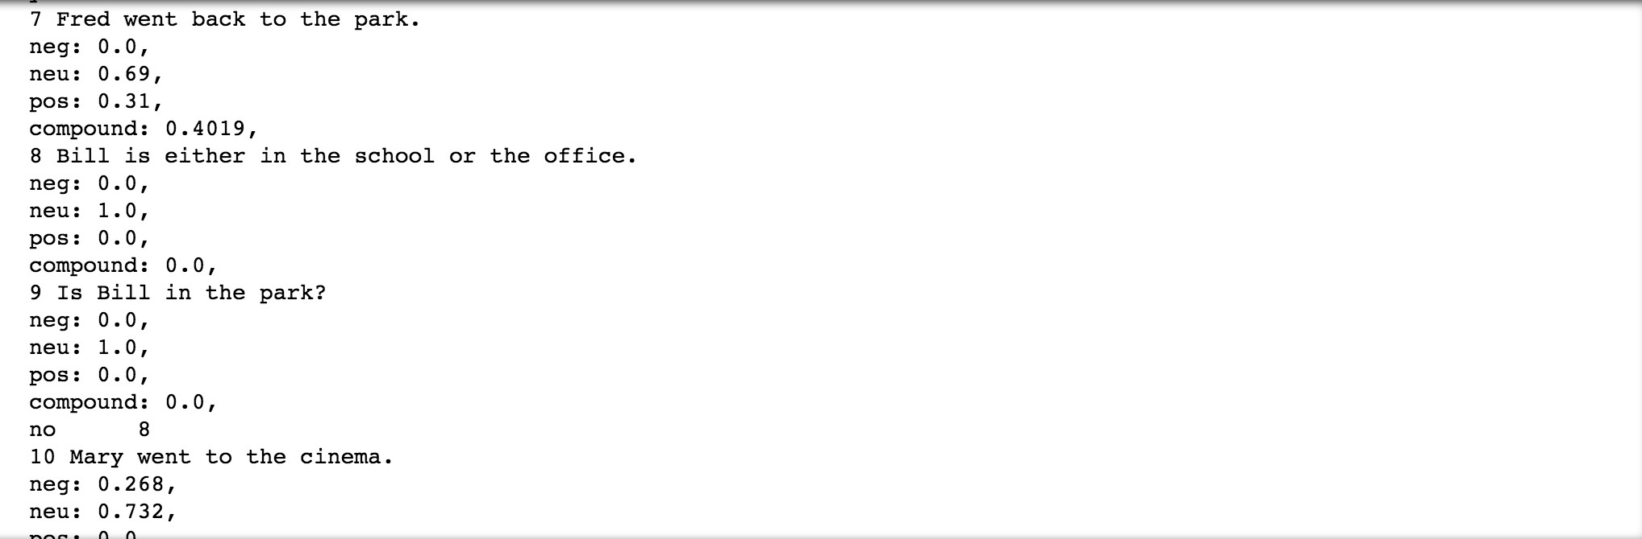

We then wanted to know the count of positive, negative, neutral and compound sentences in our dataset.

This will tell us about the intensity and sentiment of the dataset.

**Negative:**

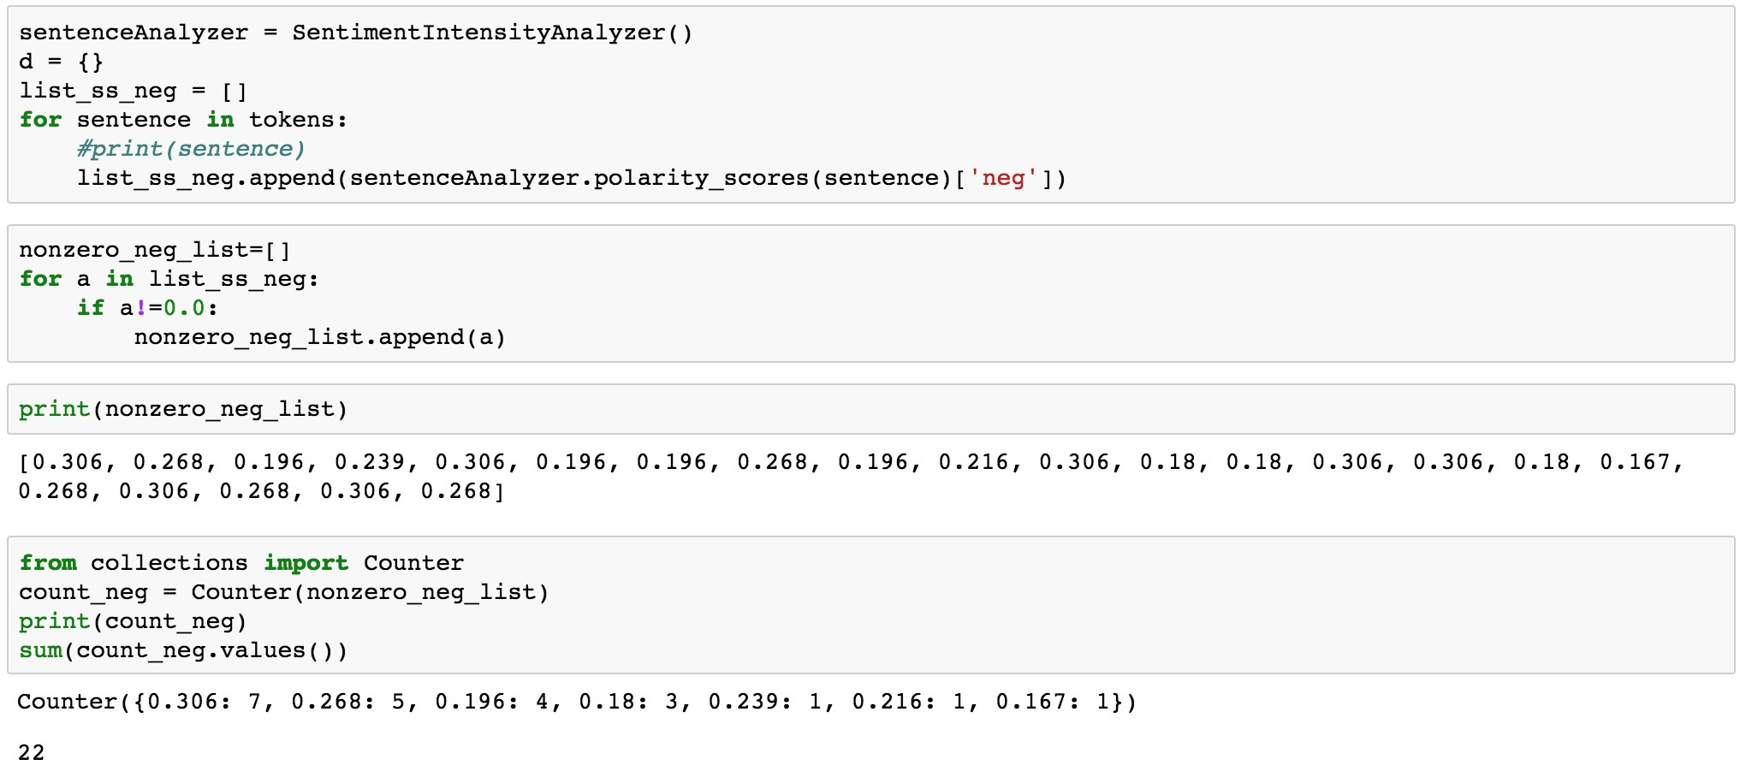

There are 22 negative questions/responses in our dataset

**Positive:**

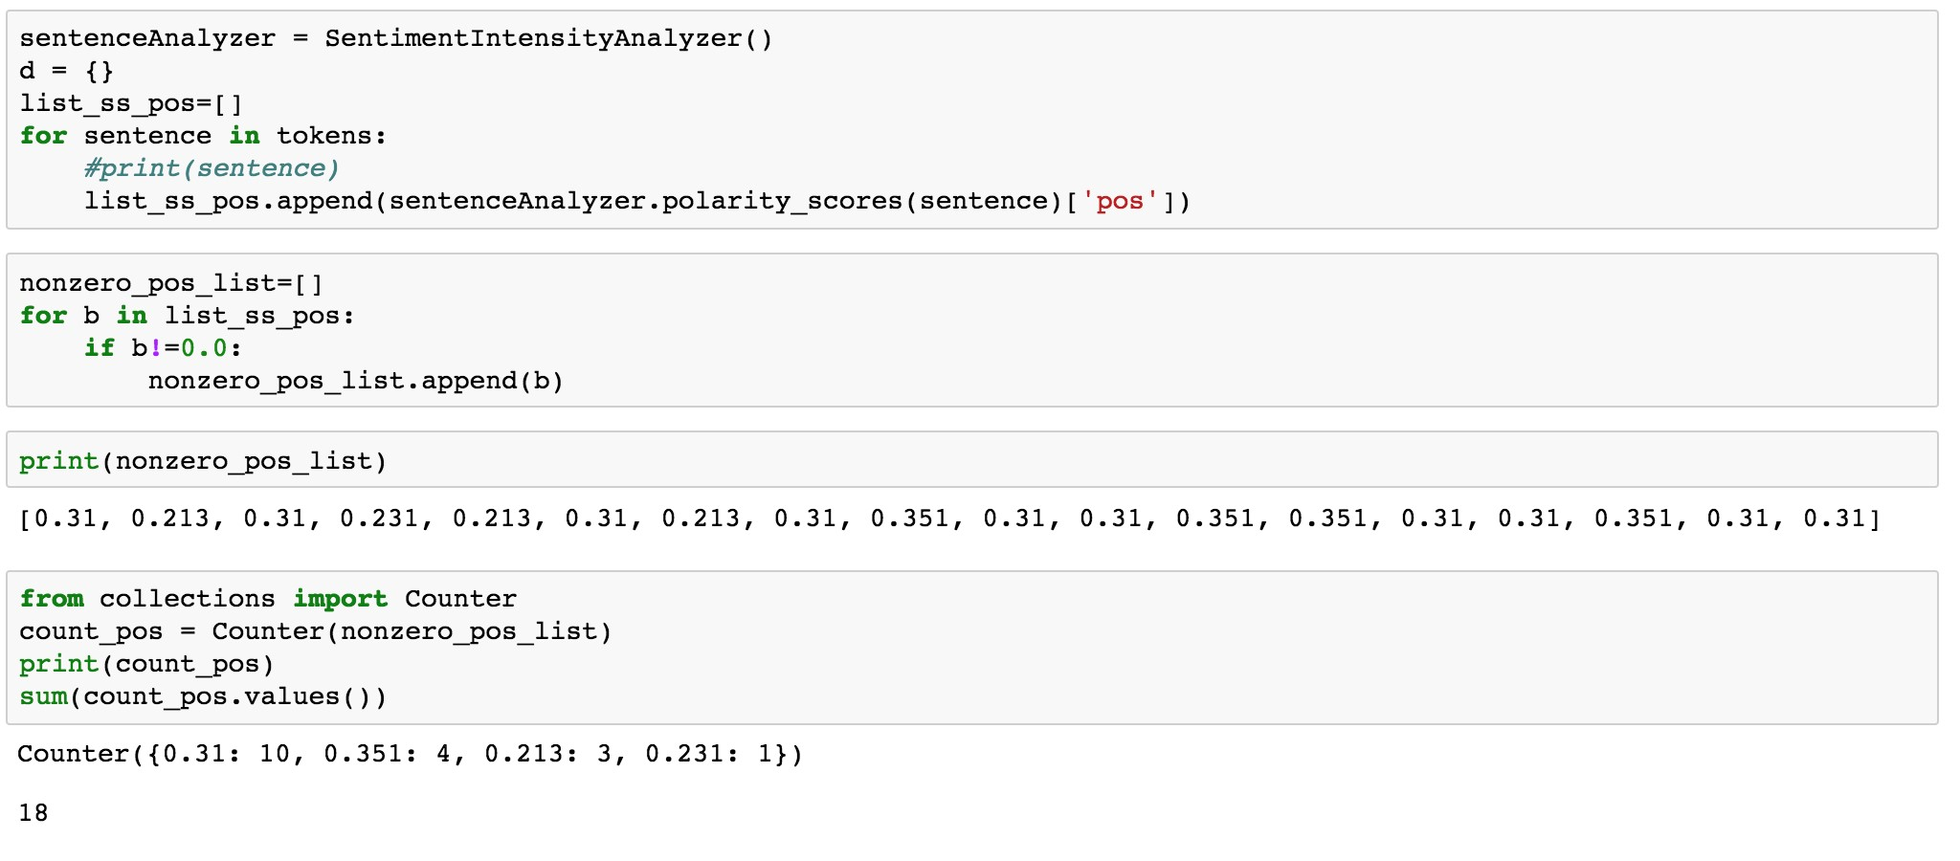

There are 18 positive questions/responses in our dataset

**Neutral:**

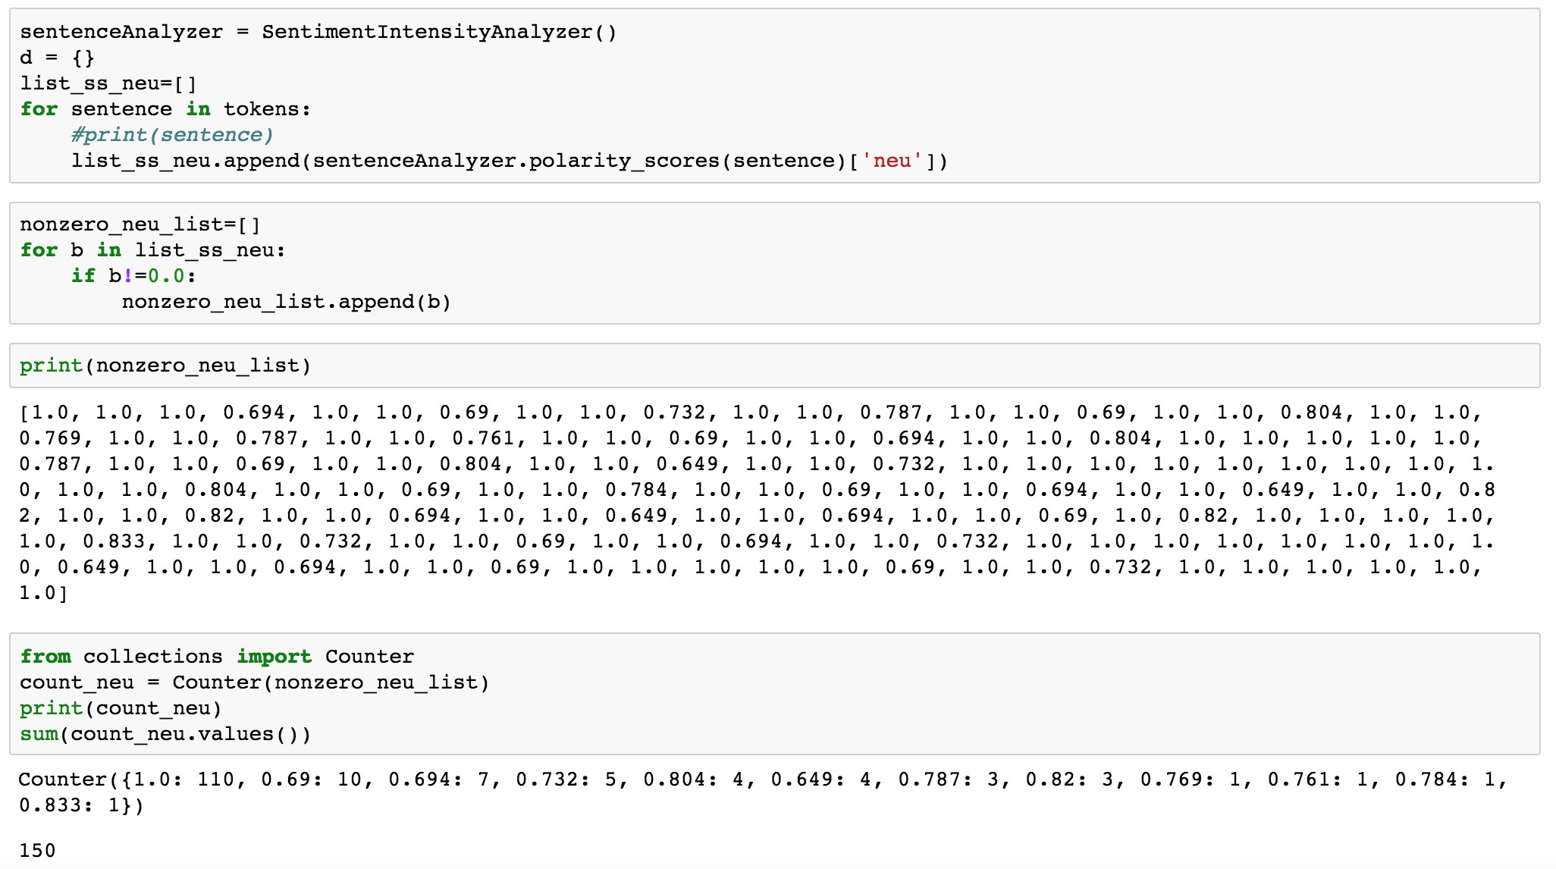

There are 150 neutral responses which can have a positive/negative intensity as well

**Compound:**

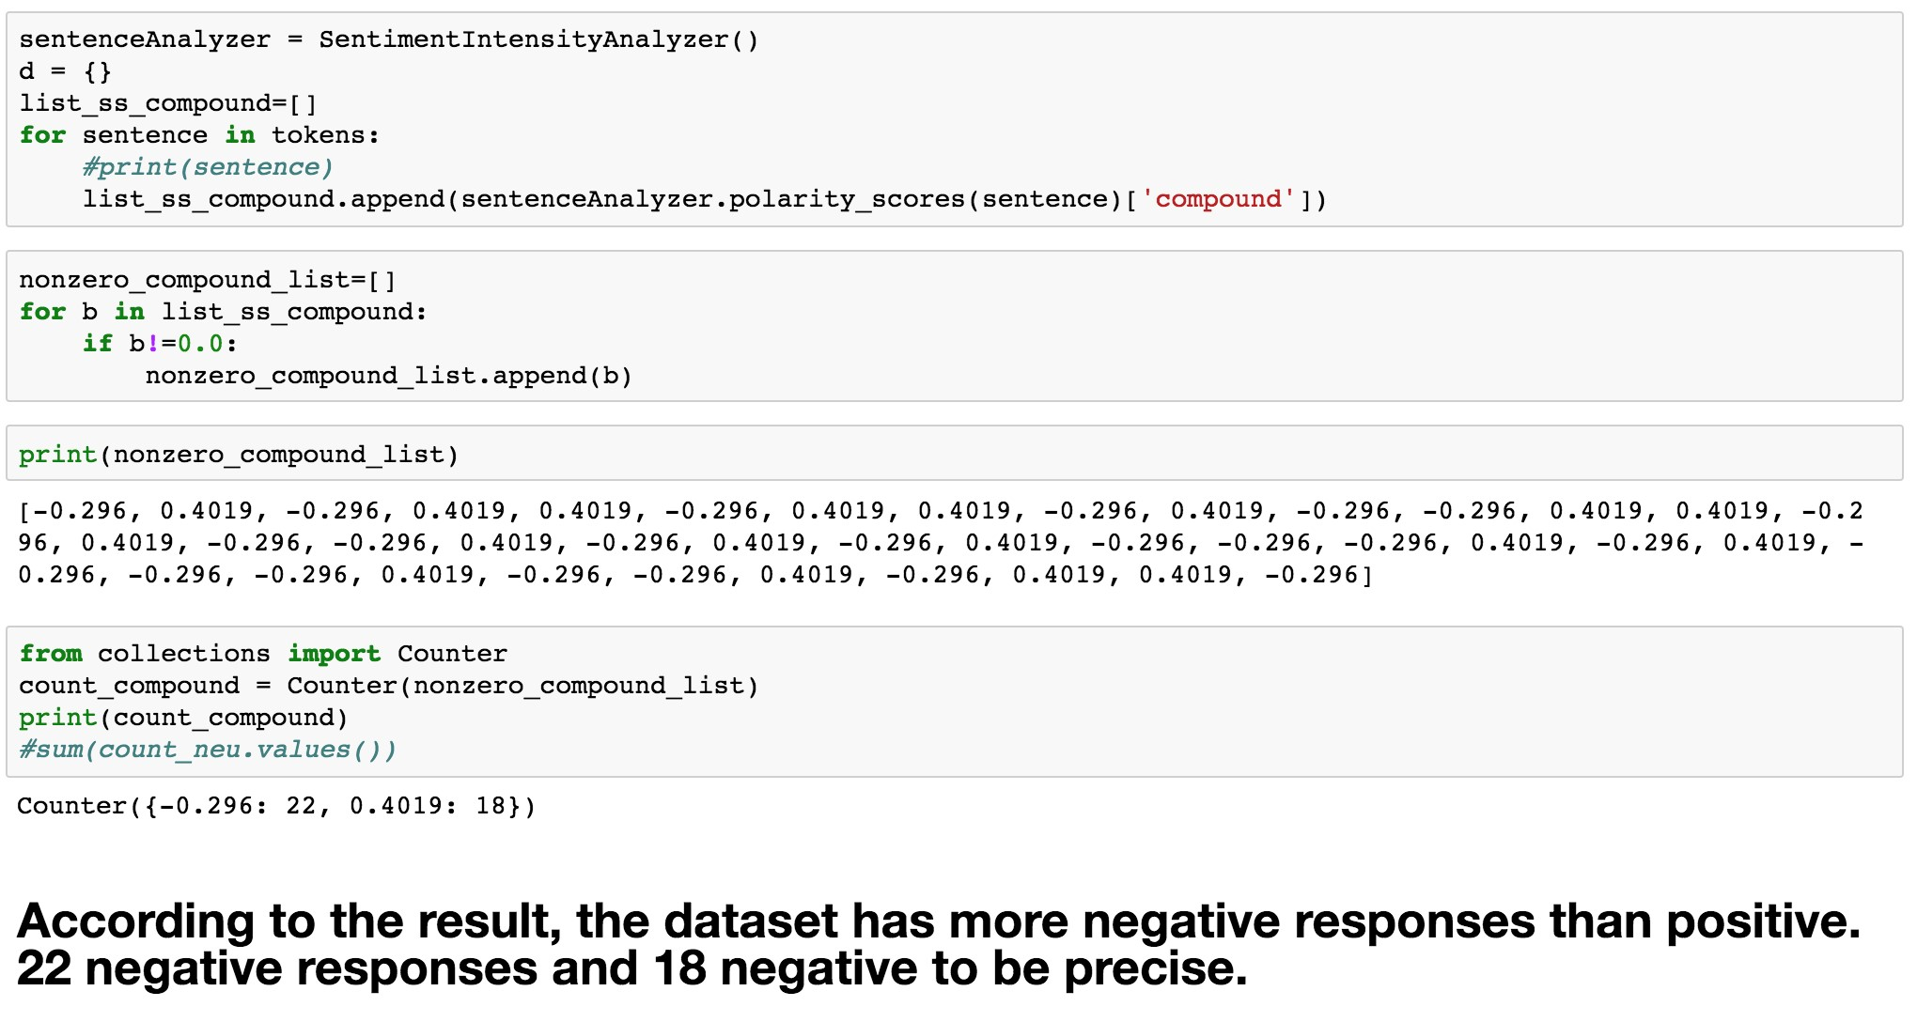

Compound score tells us how negative or how positive our dataset is. And here, the data is more negative.

**Entity Extraction and Network Analysis**



To extract meaningful information from raw text and use it to analyze the networks of individuals hidden within the data set.

To take a set of documents (in our case, training dataset), extract entities from within them, and develop a social network based on entity document co-occurrence. This can be a useful approach for getting a sense of which entities exist in a set of documents and how those entities might be related. The primary piece of software used is **Stanford Core NLP.**

**Stanford Core NLP** is one of the most popular natural language processing tools out there. It has a ton of functionality which includes part of speech tagging, parsing, lemmatization, tokenization, and what we are interested in: **named entity recognition (NER)**. NER is the process of analyzing text to find people, places, and organizations contained within the text. These named entities will form the basis of the rest of our analysis, so being able to extract them from text is critical.

Browser go to http://localhost:9000 for the tool. We receive a set of the extracted people entities from each sentence. When a text is entered, the software it gives the output as Parts-of-Speech. , named entity, dependency parse, basic and advanced dependencies for each work in the sentence.

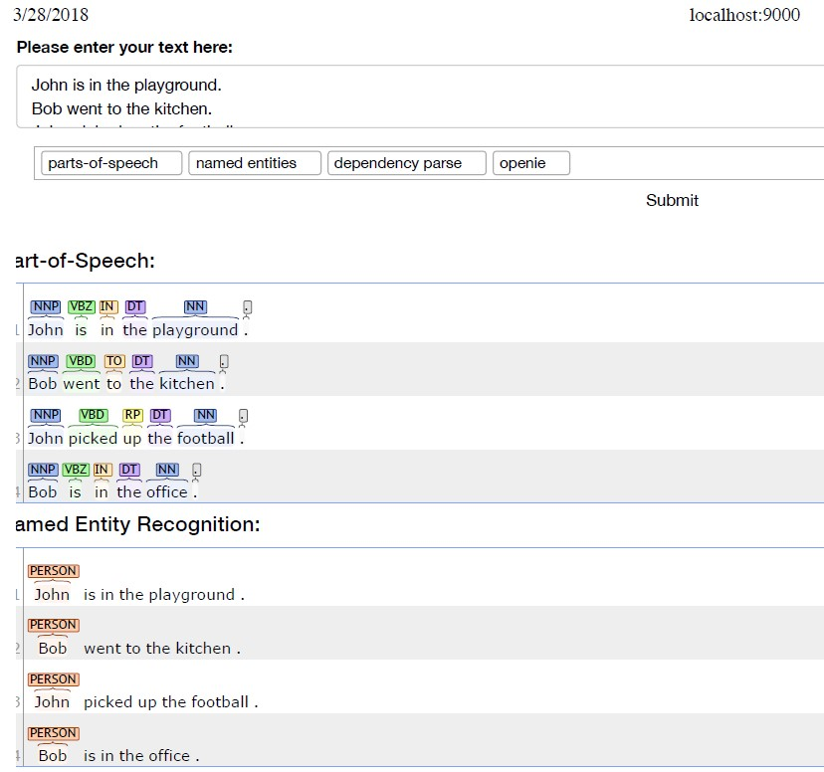

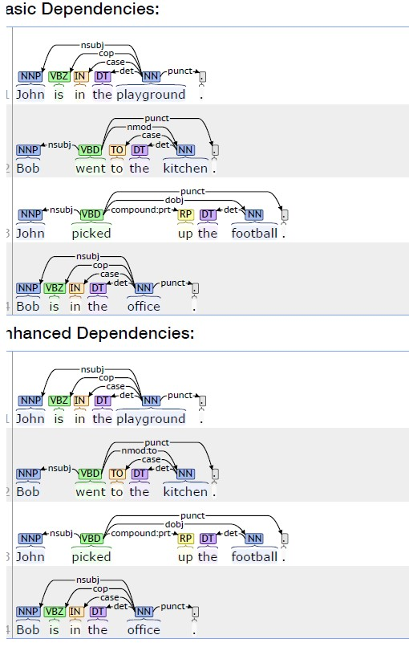

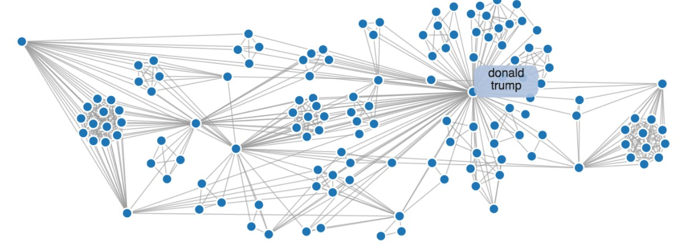

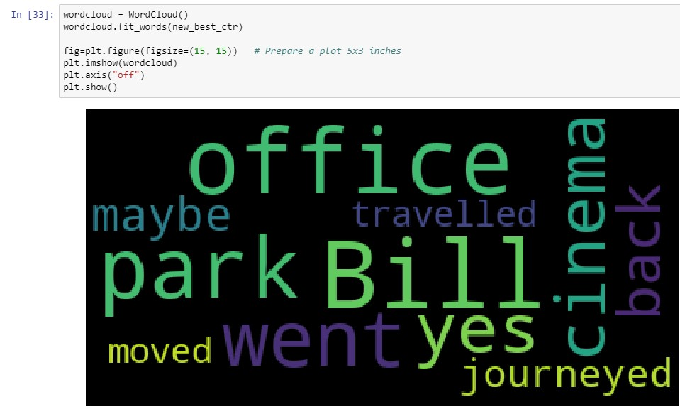

# Discussion

We have created a web application with our model to visualize the results we will get and predict from the model. Our viewpoint is that showing and visualizing the data and accuracy of the prediction on a web application made on flask, will give us a better idea of our model. This model can be enhanced even more if we had more random datasets to it giving it an ID so that the model can predict the effectiveness.

**RESULTS**

We report a variety of design choices varying memory hops from 1 to 3.

The mean performance results across all 20 tasks are given in Table 1 for the 1k training set

|  |  |  |  |
| --- | --- | --- | --- |
| Hops | 1 hop | 2 hops | 3 hops |
| Mean error (%) | 25.8 | 15.6 | 13.3 |

Table1: Shows the mean error of the 3 Hops used to train the model

# CONCLUSION

In this work we showed that a neural network with an explicit memory and a recurrent attention mechanism for reading the memory can be successfully trained via back propagation on QA tasks.

Compared to the Memory Network implementation, there is no supervision of supporting facts and so the N2N MemNet model can be used in a wider range of settings. This model approaches the same performance of that model, and is significantly better than other baselines with the same level of supervision.

On QA task we can see that increasing the number of memory hops improves performance.



# References



Data:

[1] <https://research.fb.com/downloads/babi/>

Paper:

[2] MEMORY NETWORKS Jason Weston, Sumit Chopra & Antoine Bordes, <https://arxiv.org/abs/1410.3916>

[3] End-To-End Memory Networks Sainbayar Sukhbaatar, Arthur Szlam, Jason Weston, Rob Fergus, <https://arxiv.org/abs/1503.08895>

Blog:

https://blog.csdn.net/irving_zhang/article/details/79094416

https://blog.csdn.net/Irving_zhang/article/details/7911112

<https://blog.csdn.net/irving_zhang/article/details/78113251><https://github.com/carpedm20/MemN2N-tensorflow>

https://github.com/domluna/memn2n

<https://github.com/1202kbs/MemN2N-Tensorflow>

<http://neuralnetworksanddeeplearning.com/chap1.html>

<http://www.thespermwhale.com/jaseweston/icml2016/>

<http://brandonrose.org/clustering>

<http://snap.stanford.edu/proj/embeddings-www/>